



**Revision History**

| **Date** | **Version** | **Author** | **Change Description** |
| --- | --- | --- | --- |
| 10/10/2024, 03:00 PM | 0.1 | Vo Luong | Initial creation |
| 12/10/2024, 11:16 PM | 0.2 | Vo Luong | Define application overview |
| 16/10/2024, 11:23 AM | 0.3 | Vo Luong | Upload domain model |
| 18/10/2024, 04:10 PM | 0.4 | Vo Luong | Modify domain model |
| 19/10/2024, 08:47 PM | 0.5 | Tien Minh | Upload use case diagram |
| 21/10/2024, 09:00 AM | 0.6 | Tien Minh | Write descriptions for use cases |
| 23/10/2024, 10:41 AM | 0.7 | Tien Minh | Modify the use case diagram |
| 25/10/2024, 1;27 AM | 0.8 | Tien Minh | Modify the use case diagram |
| 02/11/2024, 9:03 PM | 1.0 | Vo Luong | Modify the use case diagram |

**Approval**

| **Date** | **Version** | **Approver Name** | **Position** |
| --- | --- | --- | --- |
| 11/10/2024 | 0.1 | Dai Luong | Application Owner |
| 14/10/2024 | 0.2 | Dai Luong | Application Owner |
| 17/10/2024 | 0.3 | Dai Luong | Application Owner |
| 19/10/2024 | 0.4 | Dai Luong | Application Owner |
| 20/10/2024 | 0.5 | Dai Luong | Application Owner |
| 22/10/2024 | 0.6 | Dai Luong | Application Owner |
| 24/10/2024 | 0.7 | Dai Luong | Application Owner |
| 26/10/2024 | 0.8 | Dai Luong | Application Owner |
| 05/11/2024 | 1.0 | Dai Luong | Application Owner |

**Table of Contents**

1 Objective and Scope 4

2 Business Requirement 4

2.1. Application Overview 4

2.2. Domain Model 5

2.2.1. Diagram 5

2.2.2. Domain Objects Description 5

2.3. Workflow 7

2.4. Use Cases and Actors 9

2.4.1. Diagram 9

2.4.2. Description of Actors 10

2.4.3. Description of Use Cases 10

2.5. Security Matrix 12

3 Appendix 15

3.1. Glossary 15

3.2. Open Issues 15

# Objective and Scope

This document describes the business requirements for the MBX Project. It contains the application's overall description, the scope of data migration, and any changes that need to be performed during the migration.

This document and the prototype demo are used for requirements confirmation, and the business must sign off on them. Details of business logic and graphic user interface applications, which are not mentioned in this document, will be migrated as they are in the application.

# Business Requirement

## Application Overview

MBX is an online platform designed to buy and sell automobiles and motorcycles. Sellers can create detailed listings, providing information such as the vehicle's make, model, year, price, and condition. An administrator reviews each list to ensure the details are accurate and trustworthy. Once approved, the post becomes visible to all users. Sellers can also manage their listings and choose to boost them for increased visibility, helping them reach more potential buyers.

Buyers can easily browse available vehicles by category, price, or location. They can contact sellers directly to negotiate terms or use MBX’s secure escrow payment feature. This payment system holds the buyer’s money until they confirm that the vehicle has been delivered as agreed, ensuring a safe and transparent transaction process.

Administrators are key in maintaining the platform's safety by managing user accounts and monitoring posts. Accounts repeatedly flagged for suspicious or dishonest activity can be reviewed and banned. In addition, posts that violate MBX’s guidelines are removed to protect the integrity of the marketplace.

In addition, MBX also features a Help Center where users can find guides on how to use the platform and submit feedback to improve the service. The Customer Care team is responsible for managing user feedback and handling any issues.

With its focus on safety, transparency, and user-friendly features, MBX provides a reliable space for buying and selling vehicles securely.

## Domain Model

### Diagram

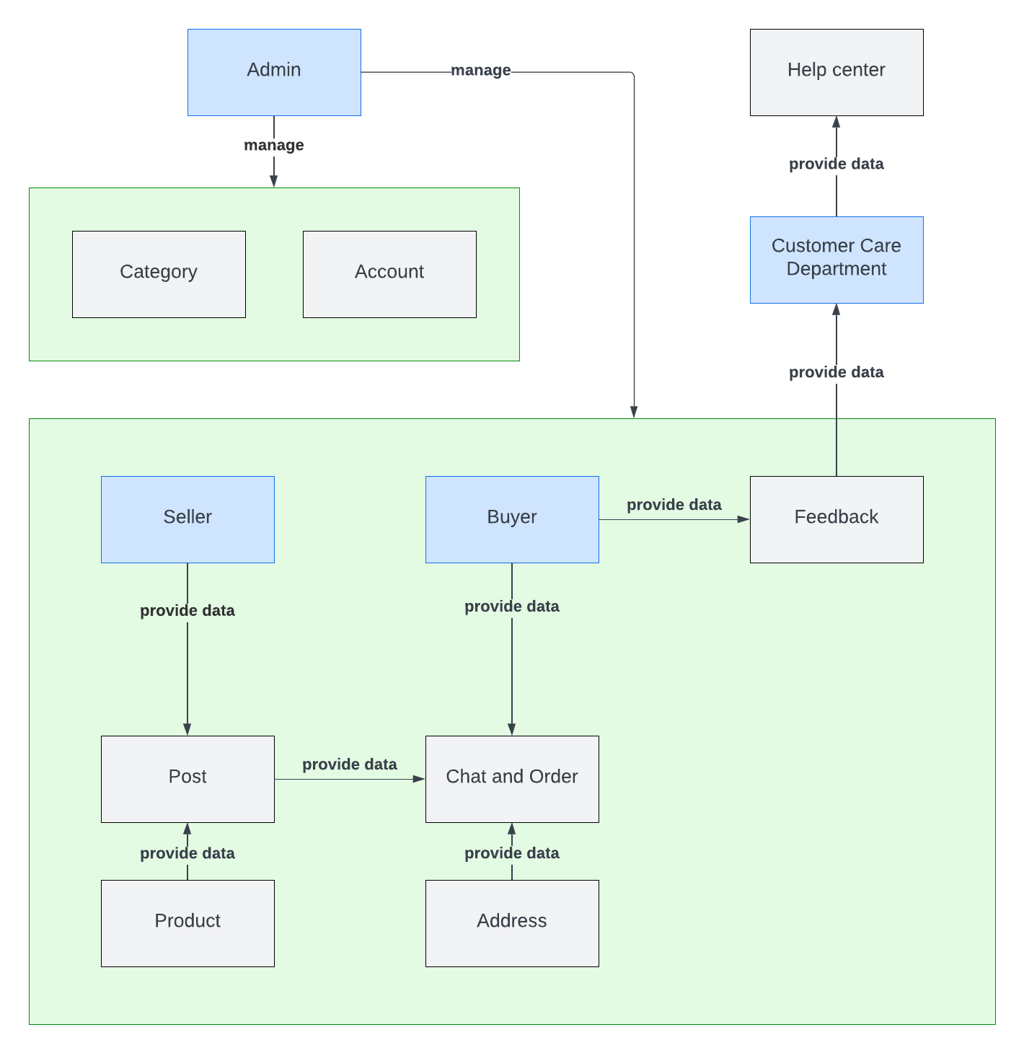

### Domain Objects Description

| # | Object Name | Object Description |
| --- | --- | --- |
| 1 | Admin | Users in this group have permission to manage user accounts and categories. |
| 2 | Seller | Users in this group have permission to manage their posts |
| 3 | Buyer | Users in this group have permission to leave feedback, chat, and order |
| 4 | Customer Care Department | Users in this group have permission to view and handle feedback from all users. |
| 5 | Category | The object contains the information of categories |
| 6 | Post | The object includes the post’s information. |
| 7 | Product | The object contains the product information, which is only created when a user creates a post. |
| 8 | Chat and Order | The object contains the buyer’s information to make an order |
| 9 | Address | The object contains the information of the shipping address. |
| 10 | Feedback | The object contains the information on feedback |
| 11 | Help Center | The object includes the Help Center’s information |

## State Diagram

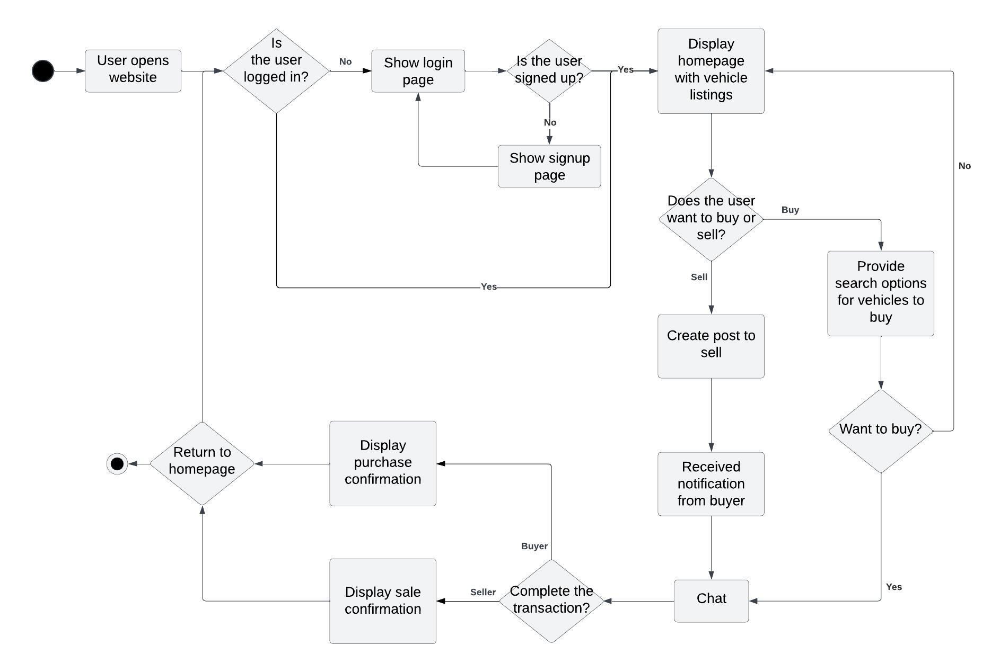

## Use Cases and Actors

### Diagram

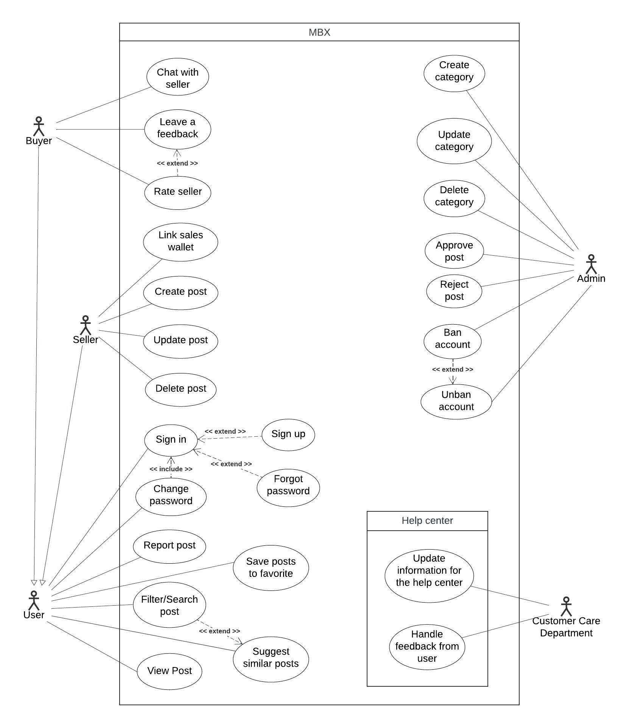

### Description of Actors

| # | Actor Name | Definition |
| --- | --- | --- |
| 1 | Admin | The administrator of the whole system is responsible for order management and post management. Admin makes sure that posts and orders are valid. |
| 2 | User | Who registers with the system |
| 3 | Seller | who wants to sell their automobiles and motorcycles |
| 4 | Buyer | Who wants to buy automobiles and motorcycles |
| 5 | Customer care department | who handle customer feedback and provide documents to the help center |

# 

### Description of Use Cases

| # | Use Case Name | Definition |
| --- | --- | --- |
| 1 | Sign In | This use case describes how a user logs into the system. |
| 2 | Sign Up | This use case describes how a user creates a new account in the system. |
| 3 | Forgot password | This use case describes how users can recover their password |
| 4 | Change password | This use case describes the process by which users can change their password |
| 5 | Leave a feedback | This use case describes how users can leave feedback |
| 6 | View Post | This use case is the process by which a user views the details of a post |
| 7 | Create post | This use case describes how users can create a post for selling electronic devices |
| 8 | Filter/Search Post | This use case allows users to filter and search for posts based on specific criteria such as keywords, categories, location, and price range |
| 9 | Save Post to Favorites | This use case allows users to save posts to their personal favorites list for easier access later |
| 10 | Suggest Similar Posts | This use case describes how the system suggests similar posts to the user based on the current post they are viewing |
| 11 | Update post | This use case describes how a user can update a post |
| 12 | Delete post | This use case describes how a user can delete a post |
| 13 | Link sales wallet | This use case describes how a user can link to their merchant wallet |
| 14 | Rate seller | This use case describes how a buyer can rate the seller after receiving the order |
| 15 | Chat with seller | This use case describes how users can contact with seller to find out more about the product |
| 16 | Report post | This use case describes how users can report violative posts |
| 17 | Create category | This use case describes how users can create new categories for the system |
| 18 | Update category name | This use case describes how a user can change the category information |
| 19 | Delete category | This use case describes how a user can delete a category |
| 20 | Approve post | This use case describes how the admin can approve a post to make it visible on the user’s wall |
| 21 | Reject post | This use case describes how the admin can reject a post due to the policy |
| 22 | Ban account | This use case describes how a user can ban a user account that violates the website’s regulations |
| 23 | Unban account | This use case describes how a user can unban a user account |
| 24 | Update information for the help center | This use case describes how users can update content and questions for the help center |
| 25 | Handle feedback from users | This use case describes how users can view and respond to customer feedback |

## Security Matrix

| Actor  Function | Admin | User | Buyer | Seller | Customer care department |
| --- | --- | --- | --- | --- | --- |
| Sign In |  | x |  |  |  |
| Sign Up | x | x |  |  |  |
| Forgot password |  | x |  |  |  |
| Change password |  | x |  |  |  |
| Leave a feedback |  |  | x |  |  |
| View post |  | x |  |  |  |
| Create post |  |  |  | x |  |
| Filter/Search Post |  | x |  |  |  |
| Save Post to Favorites |  | x |  |  |  |
| Suggest Similar Posts |  | x |  |  |  |
| Update post |  |  |  | x |  |
| Delete post |  |  |  | x |  |
| Link sales wallet |  |  |  | x |  |
| Rate seller |  |  | x |  |  |
| Chat with seller |  |  | x |  |  |
| Report post |  |  | x |  |  |
| Create category | x |  |  |  |  |
| Update category name | x |  |  |  |  |
| Delete category | x |  |  |  |  |
| Approve post | x |  |  |  |  |
| Reject post | x |  |  |  |  |
| Ban account | x |  |  |  |  |
| Unban account | x |  |  |  |  |
| Update information for the help center |  |  |  |  | x |
| Handle feedback from users |  | x |  |  | x |

## User Story

As a User, I want to be able to log in to my account and access personalized features and secure information.

As a User, I want to be able to create a new account and access the platform's features and services.

As a User who has forgotten their password, I want to be able to reset my password and regain access to my account.

As a User, I want to change my password and maintain the security of my account.

As a User, I want to provide feedback on my experience, share my thoughts, and contribute to improving the platform.

As a User, I want to filter and search posts by various criteria such as price, location, or category and quickly find posts that meet my needs.

As a User viewing a post, I want the platform to suggest similar posts and explore related items or services that match my interests.

As a User, I want to save posts to my favorites list and easily revisit them later.

As a user, I want to view the details of a specific post and get complete information about the item or service offered.

As a User, I want to create a post to sell a product and list my product for sale on the platform.

As a User, I want to be able to update the details of my selling post and modify information about the product or adjust the selling terms.

As a User, I want to be able to delete a selling post and remove the post from the platform if I no longer want to sell the product.

As a Seller, I want to link a sales wallet to my account and use it for sales transactions.

As a Buyer, I want to be able to provide a rating for a seller and share my feedback on the seller's performance.

As a User, I want to be able to initiate a chat with a seller and communicate directly with the seller for inquiries, clarifications, or negotiations.

As a registered user, I want to report a post created by another user and bring attention to inappropriate content, policy violations, or other issues.

As an Administrator, I want to create a new category and organize products and posts effectively.

As an Administrator, I want to update an existing category modify category details, and keep the system organized.

As an Administrator, I want to delete an existing category and remove unnecessary or outdated categories from the system.

As an Administrator, I want to approve a submitted post and ensure that only valid and appropriate posts are visible on the platform.

As an Administrator, I want to be able to reject a submitted post and ensure that inappropriate or non-compliant posts are not displayed on the platform.

As an Administrator, I want to ban a user account and prevent a user from accessing the platform due to violations or inappropriate behavior.

As an Administrator, I want to unban user accounts so that users who meet the criteria can regain access to the platform and continue using its features.

As a Customer Service Representative, I want to be able to update content in the Help Center and ensure that users have accurate and helpful information to address their queries.

As a Customer Service Representative, I want to manage and respond to user feedback. address user concerns, gather valuable insights, and improve the overall user experience

# Appendix

## Glossary

| Term | Description |
| --- | --- |
| BRD | Business Requirements Document |
| DB | MBX Database |
|  |  |

## Open Issues